Linux Module1 Exercise:

1. Creating users in Linux:
Which command is used to create a new user in Linux?

useradd

What is the syntax for creating a user using the useradd command?

Useradd username

Can you create a user with specific user ID (UID) and group ID (GID) using the useradd command? If yes, how?

Useradd -u 1101 -g 1101 ranjith

How can you set an initial password for a newly created user?

Passwd Ranjith
Enter new password:root
Retype password:root

What happens if you try to create a user with a username that already exists on the system?

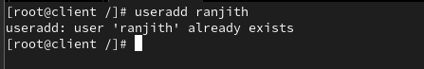

Is it possible to create a user without a home directory? If yes, how?
Its only create for user

- Create without home directory: useradd -M newuser
How can you specify the shell for a user during creation?

useradd -s /bin/bash username

Can you create a user with additional supplementary groups using the useradd command? If yes, how?

useradd -G group1,group2 username

How can you verify that a user has been successfully created?

id username or /etc/passwd

Is there a way to create a user with a specific expiration date? If yes, how?

useradd -e 2026-03-10 username

2. cat command in Linux:
What is the purpose of the cat command in Linux?

[displays file contents]

How do I use the cat command to display the contents of a file on the terminal?

[cat filename]

Can cat display the contents of multiple files at once?
[cat file1 file2]

What are some options available with the cat command, and how do I use them?
[Create file: cat > newfile (type content, Ctrl+D to save)]
How can I create a new file using the cat command?

cat > newfilename

Is it possible to concatenate multiple files using cat? If yes, how?

cat file1 file2 > combinedfile

How does the cat command handle binary files?

Use cases for binary files:
- If you want to view binary data, use tools like hexdump, xxd, or od.
- To copy binary files, cat can work (e.g., cat file.bin > output.bin), but cp is more appropriate.

Can I number the lines while displaying the contents of a file with cat?

cat -n filename
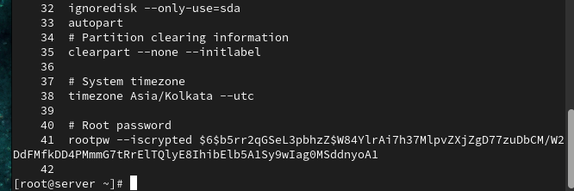

How do I suppress the display of trailing whitespace in cat output?
cat -E filename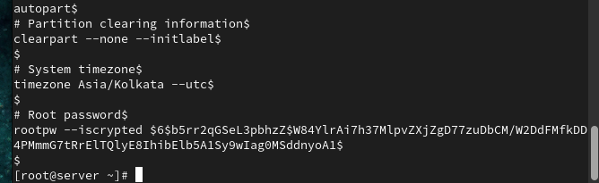

Can I use cat to append the contents of one file to another?

cat file1 >> file2
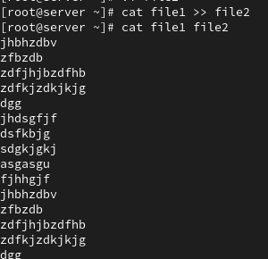

Is it possible to create a copy of a file using the cat command?

cat file1 > > file2
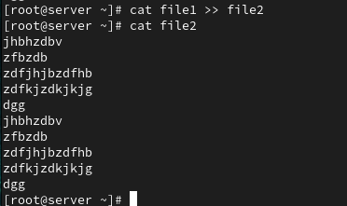

How can I use cat to display non-printing characters like tabs and newlines as visible characters?
Use cat -v (or -T for tabs, -E for line endings):

bash
cat -v file.txt # shows non-printing chars like ^I for tabs, ^M for CR
cat -ET file.txt # shows $ at EOL and ^I for tabs

What happens if I use cat with multiple files, but some of them do not exist?

If some files don’t exist, cat will:
- Print contents of existing files.
- Show an error for missing files (stderr) and exit with non-zero status.
Example:
cat file1.txt nonexistent.txt file2.txt

Can cat be used to view the contents of remote files over SSH?

How does the cat command handle files with very long lines?

cat filename | less

3. “ls” command in Linux:

What is the purpose of the ls command in Linux?

The ls command lists files and directories in Linux.

How do I use the ls command to list files and directories in the current directory?
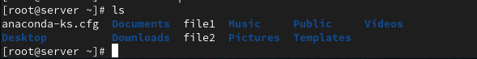

Can ls display file and directory details, such as permissions, owner, size, and modification date?

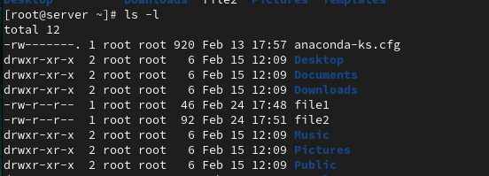

How can I list files and directories in a specific directory other than the current one?

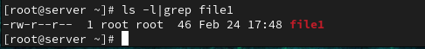

What are some common options that can be used with the ls command, and how do I use them?

Common options:
- -a: include hidden files
- -l: long format
- -h: human-readable sizes (e.g., KB, MB)
- -R: recursive list
- -t: sort by mod time
- -S: sort by size

How can I make ls show hidden files and directories?

Ls -a its shows . values also called as hidden files.
Is it possible to list files and directories in a long format with human-readable file sizes?

ls -lh

How do I sort the ls output by different criteria, such as name, size, or modification time?

- ls -t: by mod time (newest first)
- ls -S: by size (largest first)
- ls -r: reverse order

ls -lt # sort by time
ls -lSr # sort by size, reverse

Can ls display files and directories with color-coded output?

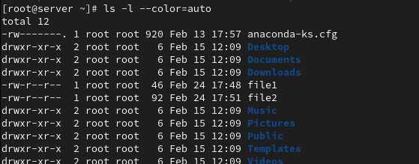

How can I recursively list files and directories within subdirectories?

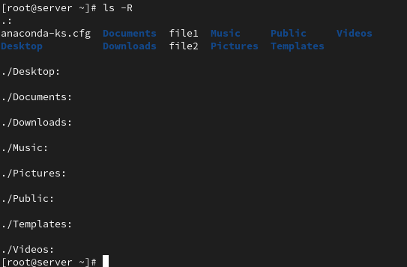

What is the difference between ls and ls -l in terms of the information they display?

- ls: brief list (names only)
- ls -l: detailed list (permissions, size, etc.)

How can I use ls to find files that match a specific pattern or extension?
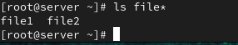

Can ls display file sizes in units other than bytes, such as kilobytes or megabytes?

Use -h for human-readable (K, M, G):
ls -lh

How do I use ls to list only directories, excluding regular files?
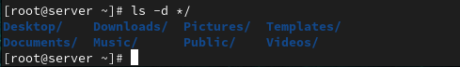

What happens if I use ls with a directory that I don't have permission to access?

ls will error:

ls: cannot open directory 'dir': Permission denied

4. Creating directories in Linux:
Which command is used to create a new directory in Linux?

[Mkdir]

What is the syntax for creating a directory using the mkdir command?
Mkdir directoryname

Can you create multiple directories at once using the mkdir command? If yes, how?

mkdir dir1 dir2 dir3
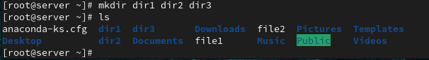

How can you specify the full path for creating a directory in a specific location?

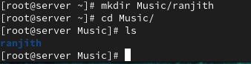

What happens if you try to create a directory with a name that already exists in the current location?

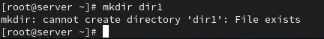

Is it possible to create a directory with a space in its name? If yes, how?

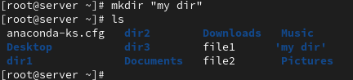

How can you verify that a directory has been successfully created?

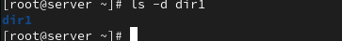

Is there a way to create directories with specific permissions using the mkdir command?

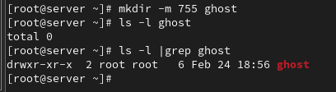

How can you create nested directories (directories within directories) using the mkdir command?

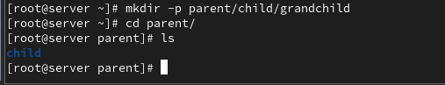

Can you create a directory with a relative path instead of an absolute path? If yes, how?
Relative path:
mkdir subdir
# creates in current dir
Absolute path:
mkdir parent/child/grandchild

5. copy (cp), move (mv), and remove (rm) commands for files and directories in Linux:
Copy (cp):
How do I copy a file to a different directory using the cp command?

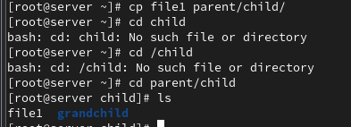

Can I preserve the original file permissions when copying with cp?

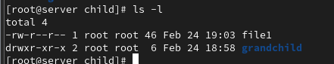

How can I copy multiple files at once using the cp command?

Is it possible to overwrite an existing file when copying with cp?

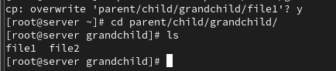

How can I copy a directory and its contents using cp?
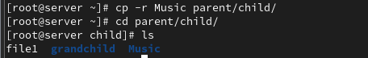

Move (mv):
How do I move a file to a different directory using the mv command?

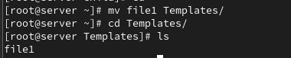

Can I rename a file while moving it with the mv command?
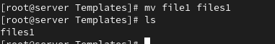

What happens if I move a file to a directory where a file with the same name already exists?

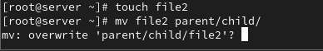

How can I move multiple files at once using the mv command?

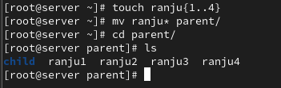

Is it possible to move a directory and its contents using mv?

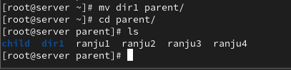

Remove (rm):
How do I remove a file using the rm command?
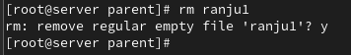

Can I remove multiple files at once using the rm command?
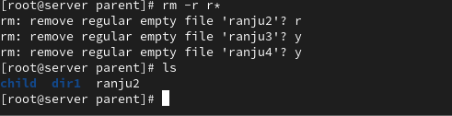

How can I remove a directory and its contents using the rm command?
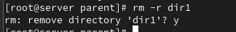

What happens if I try to remove a file that is write-protected or has special permissions?
Is there a way to force the removal of files or directories using rm?

Rm -rf
This command is used for delete the files or directory forcefully.

6. File & Dir permissions
Here are some sample questions to test your knowledge of file and directory permissions in Linux:
What are the three basic permissions for a file in Linux?

- r (read)
- w (write)
- x (execute)

How are file permissions represented in the output of the ls -l command?

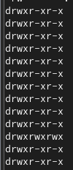

What does the "r" permission indicate for a file? What about the "w" and "x" permissions?
- r: read file contents
- w: modify/write file
- x: execute file (run as program/script)

How can you change the permissions of a file using the chmod command?

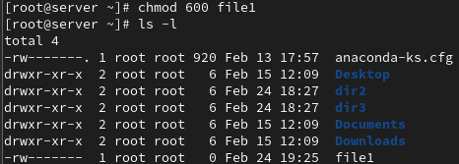

What does the numeric representation 644 mean in terms of file permissions?

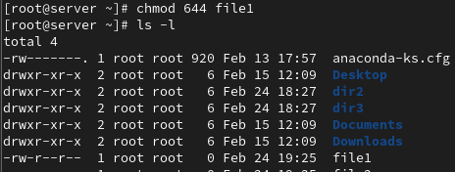

Full permission of the file .Because everyone access the file.

How can you change the permissions of a directory in Linux?
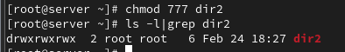

What does the "x" permission mean for a directory?

Execute: ability to cd into dir or traverse it.

How do you recursively change the permissions of all files and directories within a directory?
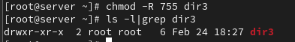

What is the difference between the chmod command and the chown command?

- chmod: changes permissions
- chown: changes owner/group

How can you check the permissions of a directory using the ls command?

7. Vi editor in Linux:
What is the purpose of the Vi editor in Linux?
[The Vi editor is a powerful, terminal-based text editor in Linux, widely used for creating and editing files.]

What is the command to open a file in Vi for editing?

[Vi filename]

How do you switch to insert mode in Vi to start adding or modifying text?

- i: Insert text before the cursor
- a: Insert text after the cursor
- o: Open a new line below the current line and enter insert mode
- I: Insert text at the beginning of the line
- A: Insert text at the end of the line
- O: Open a new line above the current line and enter insert mode

How do you save changes and exit Vi?
- :wq or ZZ: Save and quit
- :w: Save changes without exiting

What is the command to exit Vi without saving changes?
- :q: Quit without saving (if no changes made)
- :q!: Force quit without saving

How can you move the cursor to the beginning and end of a line in Vi?

- 0 or ^: Move to the beginning of the line
- $: Move to the end of the line
- h, j, k, l: Move left, down, up, right
- w: Move to the next word
- b: Move to the previous word
- G: Move to the last line
- gg: Move to the first line

What is the command to search for a specific word or pattern in Vi?

- /pattern: Search forward for a pattern
- ?pattern: Search backward for a pattern
- n: Find the next occurrence
- N: Find the previous occurrence

How can you delete a character or a line in Vi?
- x: Delete a single character
- dd: Delete the current line
- dw: Delete a word
- D: Delete from the cursor to the end of the line

How do you copy and paste text in Vi?
- yy: Copy (yank) the current line
- yw: Copy a word
- p: Paste after the cursor
- P: Paste before the cursor

What are some basic navigation commands in Vi to move between different sections of a file?

- Ctrl+f: Move forward one screen
- Ctrl+b: Move backward one screen
- Ctrl+d: Move down half a screen
- Ctrl+u: Move up half a screen

How do you search for a specific word or phrase in Vi?
- Case Sensitivity: By default, Vi searches are case-sensitive. To ignore case, add \c after your search term, like /example\c.
- Whole Word Search: Use \< and \> to search for whole words, like /\<example\>.
- Next Occurrence: Press n to move to the next occurrence, and N to move to the previous one.
- Highlight Search Results: Use :set hlsearch to highlight all search results.

What is the difference between the :w and :wq commands in Vi?

- :w: Saves changes without exiting Vi
- :wq: Saves changes and exits Vi

How do you delete a single character in normal mode?
x: Delete the character under the cursor

8. Special permissions in Linux:
What are the three special permissions in Linux?
1. Setuid (SUID)
2. Setgid (SGID)
3. Sticky Bi

What is the purpose of the setuid permission?

The setuid permission allows an executable file to run with the owner's permissions, rather than the user's.

How is the setuid permission represented in the output of the ls -l command?

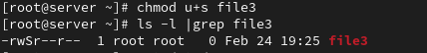

What is the effect of the setuid permission on an executable file?
The setuid permission causes the executable file to run with the owner's permissions, not the user's.

What is the purpose of the setgid permission?
The setgid permission has two purposes:
- For files, it runs the file with the group permissions.
- For directories, new files inherit the directory's group.

How is the setgid permission represented in the output of the ls -l command?

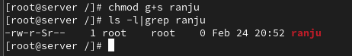

What is the effect of the setgid permission on a directory?
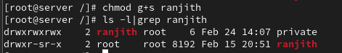

What is the purpose of the sticky bit permission?
The sticky bit permission restricts file deletion in directories; only the owner, directory owner, or root can delete files.

How is the sticky bit permission represented in the output of the ls -l command?
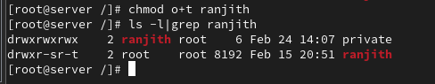

What is the significance of the sticky bit on a directory?
The sticky bit on a directory prevents accidental or malicious file deletion in shared directories like /tmp. Only the owner, directory owner, or root can delete files.

9. User and Group administration in Linux:

What is the command to create a new user in Linux?

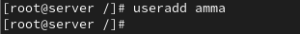

How can you specify a user's home directory during user creation?

How do you assign a password to a user account in Linux?
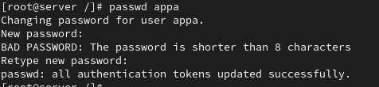

What command is used to delete a user from the system?
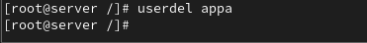

How can you add an existing user to a specific group?
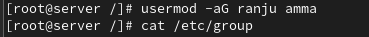

What command is used to create a new group in Linux?

How do you add a user to a newly created group?

usermod -aG groupname username

What is the purpose of the chgrp command?

chgrp changes the group ownership of a file or directory.

How can you list all the users on a Linux system?

Cat /etc/passwd

What command can you use to modify a user's account settings, such as their shell or home directory?
[Usermod]
Usermod -s /bin/bash username
Usermod -d /home/newdir username

How do you list all the users on a Linux system?

Cat /etc/passwd

What command is used to add a new user in Linux?

Useradd username

Ex :
Useradd ranjith

How can you assign a user to a specific group during user creation?
Useradd -g groupname username

Ex:
Useradd -g amma ranjith

What is the purpose of the usermod command?

usermod modifies a user's account settings.

How do you change a user's password in Linux?

passwd username

How do you lock or unlock a user account using the passwd command?

Passwd -l username

What is the purpose of the groupadd command?

Groupadd command is used to create a new group in Linux

How do you add an existing user to an existing group?

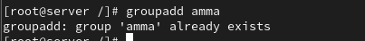

How can you remove a user from a group?

gpasswd -d username groupname
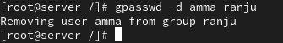

What command is used to delete a user account in Linux?

Userdel username

How do you display the details of a specific user, including their group memberships and other information?

id username

How can you create a new group and set its GID (Group ID) using the groupadd command?

groupadd -g GID groupname

What is the difference between the useradd and adduser commands?
useradd is a low-level command, while adduser is a higher-level command that provides more interactive options.

How can you list all the groups on a Linux system?
cat /etc/group

What is the purpose of the /etc/passwd file in Linux?

The /etc/passwd file stores user account information.

What information does each line in the /etc/passwd file represent?

Each line represents a user account, with fields for username, password, UID, GID, and more.

How can you view the contents of the /etc/passwd file?

cat /etc/passwd

What is the purpose of the /etc/shadow file?

The /etc/shadow file stores password hashes and other security information.

How is the /etc/shadow file different from the /etc/passwd file?
/etc/shadow contains security information, while /etc/passwd contains public users information

How can you view the contents of the /etc/shadow file?

What is the purpose of the /etc/gshadow file?
The /etc/gshadow file stores group password hashes and other security information

How is the /etc/gshadow file different from the /etc/group file?

/etc/gshadow contains sensitive information, while /etc/group contains public information.

How can you view the contents of the /etc/gshadow file?

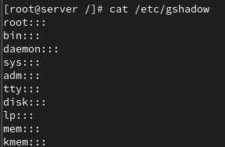

What is the purpose of the /etc/group file in Linux?

The /etc/group file stores group information.

How can you view the contents of the /etc/group file?

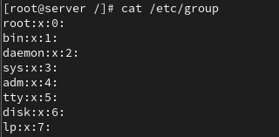

What information does each line in the /etc/group file represent?
Each line represents a group, with fields for group name, password, GID, and members.

How can you add a new user to the /etc/passwd file and assign them to a group?
useradd -G groupname username

How do you lock or disable a user account in the /etc/shadow file?

passwd -l username

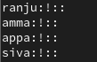

What command is used to modify user group memberships in the /etc/group file?

Usermod

Ex:
Usermod -aG groupname username

10. Processes in Linux:
What is a process in Linux?
A process is an instance of a running program. It contains the program code and its current activity (memory, registers, etc.).

How can you view the currently running processes in Linux?
Use the ps command or top to see active processes.

What command is used to start a new process in Linux?
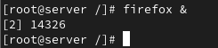

How can you identify the process ID (PID) of a running process?
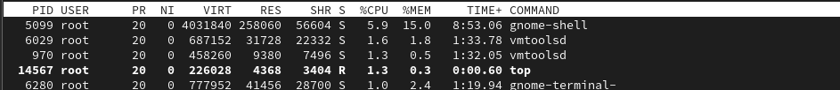

What is the purpose of the ps command in Linux?
ps displays information about currently running processes (PID, user, CPU%, memory, etc.).
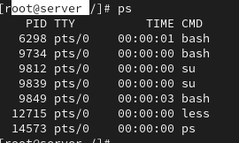
How can you terminate a process in Linux?

kill -9 <PID>

ex:
kill -9 12715

What is the difference between a foreground process and a background process?

- Foreground: runs interactively, occupying the terminal until it finishes.
- Background: runs independently, freeing the terminal for other commands.

How do you start a process in the background in Linux?

Append & to the command: myprogram &.

How can you check the status of a specific process in Linux?

top -p <PID>.
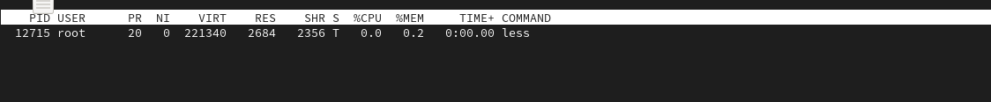
What is a parent process and a child process in Linux?
- Parent process: the process that creates another process.
- Child process: the newly created process (spawned by a parent)

How can you change the priority of a process in Linux?

nice -n 10 myprogram # start with lower priority
renice 5 -p <PID> # change priority of existing process

What is the purpose of the top command in Linux?

top provides a dynamic, real-time view of system processes, CPU, and memory usage.

How can you monitor the resource usage of a process in Linux?

Use top, htop, or pidstat to see CPU/memory usage per process.

What is the significance of the process states, such as "Running," "Sleeping," and "Zombie"?

- Running: actively using CPU.
- Sleeping: waiting for an event (I/O).
- Zombie: terminated but its entry remains in the process table (parent hasn’t read its exit status).

How can you send signals to a running process in Linux?

Use the kill command: kill -SIGNAL <PID>. Common signals: SIGTERM (15), SIGKILL (9).
Ex:
Kill -SIGNAL 12715

How do I run the top command?
top
What information does the top command display?

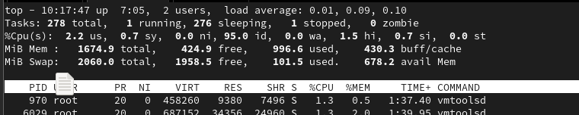

How do I interpret the CPU usage information shown by top?

It shows system summary (uptime, load, CPU%, memory) and a list of processes with PID, user, %CPU, %MEM, command, etc.

How can I sort processes based on different criteria (e.g., CPU usage, memory usage) in top?

Press P (shift+p) for CPU sort, M (shift+m) for memory sort, or T for time.

Is it possible to change the update frequency of top to see real-time changes more or less frequently?

Use top -d <seconds> (e.g., top -d 1 for 1‑second updates). In interactive mode, press d to set delay.

How can I view only the processes of a specific user with top?
top -u <username>
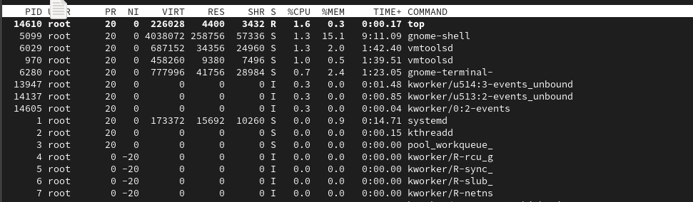

What are the basic navigation keys in top for sorting and filtering processes?

- P: sort by CPU.
- M: sort by memory.
- N: sort by PID.
- k: kill a process.
- r: renice a process.

Can top show the full command line used for each process?

Press c to toggle full command line display.

How do I kill a process directly from top?

Can top show the overall memory and CPU usage summary for the system?

Yes, the header displays total CPU%, memory, and swap usage.

Is there a way to display the top output in a non-interactive mode (e.g., for scripting purposes)?

Use top -b -n 1 for batch mode (single snapshot).

What do the different colors and flags represent in the top output?
Colors (if enabled) highlight tasks (e.g., red for high CPU). Flags indicate process states (S = sleeping, R = running).

How can I adjust the priority of a process using top?

Press r, enter the PID, then specify the new nice value.

Are there alternative commands or utilities similar to top for monitoring system performance?

htop, glances, atop, or vmstat.

How can I save the top output to a file for later analysis?

top -b -n 1 > output.txt

How can you terminate a process in Linux?

kill -9 <PID>

What is the difference between a foreground process and a background process?

Foreground occupies the terminal; background runs independently.

How do you start a process in the background in Linux?

Add & to the command: command &.

How can you check the status of a specific process in Linux?
top -p <PID>.

What is a parent process and a child process in Linux?

Parent creates a child process; child inherits environment.

How can you change the priority of a process in Linux?
nice (start) or renice (adjust).
Enter r in top running time

What is the purpose of the top command in Linux?

Real‑time system & process monitoring.

How can you monitor the resource usage of a process in Linux?
Use top, htop, or pidstat

What is the significance of the process states, such as "Running," "Sleeping," and "Zombie"?
Indicate execution status and resource waiting.

How can you send signals to a running process in Linux?

kill -SIGNAL <PID>.

11. Services in Linux:
What is a service in the context of Linux?
A service in Linux is a background program (daemon) that runs continuously to provide system functionality such as networking, web hosting, or printing.
Example services:
- Web server
- Database server
- SSH server

How can you check the status of a service in Linux?

systemctl status servicename

What command is used to start a service in Linux?

systemctl status sshd
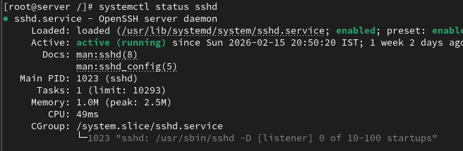

How can you stop a running service in Linux?

What is the purpose of the systemctl command in Linux?
systemctl is used to control and manage system services using the systemd service manager.
Functions include:
- Start services
- Stop services
- Restart services
- Enable or disable services
- Check service status

How can you enable a service to start automatically at system boot in Linux?

systemctl enable httpd

What is the difference between a system service and a user service in Linux?

System Service | User Service
Runs at system level | Runs for a specific user
Started during system  boot | Started when user logs in
Managed by root | Managed by user

How can you restart a service in Linux?

systemctl restart httpd

What command is used to view the list of available services in Linux?

systemctl list-units --type=service
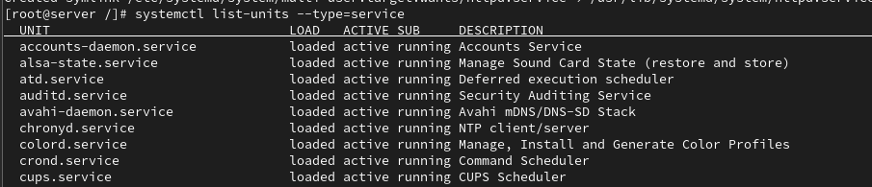

How can you configure the behavior and settings of a service in Linux?
Vi /etc/selinux/conf

Use this type of configuration files to modify its process

What is the purpose of the /etc/init.d directory in Linux?

/etc/init.d contains startup scripts for services used by the older SysVinit initialization system.

/etc/init.d/httpd start

How can you create a custom service in Linux?

vi /etc/systemd/system/myservice.service
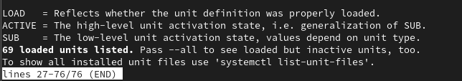

How can you check the logs and debug a service in Linux?
journalctl -u servicename
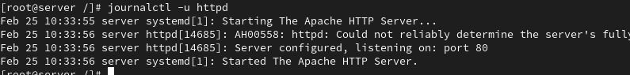

What is the significance of service dependencies in Linux?
Service dependencies ensure that services start in the correct order.

12.Archiving and transferring files in Linux:
What command is used to create a tar archive of files and directories in Linux?
Use the tar command.
tar -cvf archive.tar ranjith/
c → create archive
v → verbose (show files being processed)
f → file name of archive

How can you extract files from a tar archive in Linux?

tar -xvf archive.tar
x - extract

What is the purpose of compression when creating an archive?
Compression is used to:
- Reduce file size
- Save disk space
- Make file transfer faster
- Combine multiple files into one compressed package

Which command is used to compress files into a gzip archive in Linux?

gzip filename

filename.gz

tar -czvf archive.tar.gz folder/

How can you extract files from a gzip archive in Linux?
tar -xzvf archive.tar.gz

How can you extract files from a bzip archive in Linux?

tar -xjvf archive.tar.bz2
j → bzip2 compression

What is the difference between a tar archive and a compressed archive?

Tar Archive | Compressed Archive
Combines multiple files into one  file | Reduces file size
Does not reduce size by default | Uses algorithms like gzip or bzip2
Example: .tar | Example: .gz, .bz2, .zip
.tar → archive only
.tar.gz → archive + gzip compression
.tar.bz2 → archive + bzip2 compression

How can you create a zip archive of files and directories in Linux?

zip -r archive.zip folder/
r → recursive (include directories)

What command is used to extract files from a zip archive in Linux?

unzip archive.zip

How can you transfer files between Linux systems using the scp command?

scp file.txt user@remote_ip:/home/user/

What is the syntax for transferring a file using scp?

scp source_file username@remote_host:destination_path

scp test.txt user@192.168.1.10:/home/user/

How can you transfer an entire directory using scp?

scp -r folder/ user@192.168.1.10:/home/user/

-r → recursive copy of directory

13. Analyzing and storing logs in Linux:
What is the purpose of log files in Linux?

Log files store system activity information such as:
- System events
- Errors and warnings
- Security activities
- Application activity
- Troubleshooting information

How can you view the contents of a log file in Linux?

cat /var/log/messages

What command is used to search for specific keywords or patterns within a log file?

Use the grep command.
grep "error" /var/log/messages
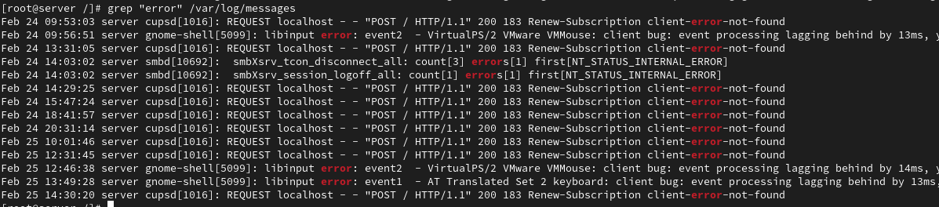

How can you filter log entries based on specific criteria using the grep command?

Case-insensitive search:
grep -i "error" /var/log/syslog
Search multiple patterns:
grep -E "error|warning" /var/log/syslog

What is the purpose of log rotation in Linux?

Log rotation:
- Prevents log files from becoming too large
- Archives old logs
- Frees disk space
- Maintains logs for a specific period
How can you configure log rotation for a specific log file?
sudo vi /etc/logrotate.conf
Example configuration:
/var/log/myapp.log {
weekly
rotate 4
compress
}
What is the significance of log levels in log files?

Level | Meaning
DEBUG | Debugging information
INFO | General information
WARNING | Possible issue
ERROR | Error occurred
CRITICAL | Serious failure

How can you analyze logs for errors and warnings using regular expressions?

grep -E "error|warning|fail" /var/log/messages
This command searches for:
- error
- warning
- fail
in the log file.

What are some commonly used log files in Linux?

Log File | Purpose
/var/log/messages | General system messages
/var/log/syslog | System activity logs
/var/log/auth.log | Authentication logs
/var/log/secure | Security logs
/var/log/dmesg | Kernel boot messages
/var/log/cron | Cron job logs

How can you monitor log files in real-time using the tail command?

tail -f /var/log/messages
- -f → follow the log in real time
Useful for live monitoring of system activity.
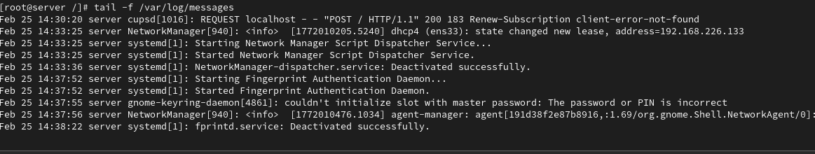

What is the purpose of log analyzers and monitoring tools in Linux?

Log analyzers help to:
- Detect system problems
- Monitor security threats
- Analyze server performance
- Generate reports and alerts

How can you store logs remotely using a centralized logging server?

Use remote logging services like:
- rsyslog
- syslog-ng
Example configuration:
Edit:
/etc/rsyslog.conf
Add:
*.* @192.168.1.100:514
What is the role of the /var/log directory in Linux?
/var/log is the main directory where Linux stores log files

14. RPM packages in Linux:
What is an RPM package in Linux?
An RPM package is a software package format used in Red Hat–based Linux distributions such as Red Hat Enterprise Linux, CentOS, and Fedora.
It contains:
- Application software
- Configuration files
- Metadata (version, dependencies, description)
RPM makes installation, updating, and removal of software easier.

How can you install an RPM package in Linux?
rpm -ivh package_name.rpm

What command is used to query information about an installed RPM package?
rpm -qi httpd
This displays:
- Package name
- Version
- Release
- Description
- Installation date
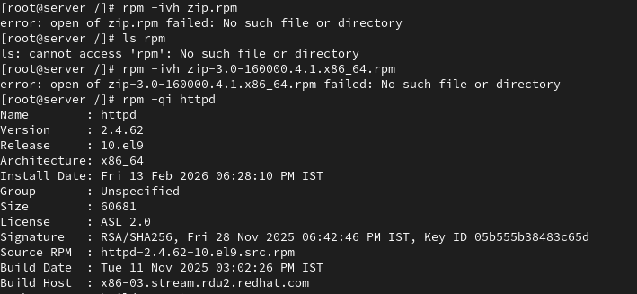
How can you list all the files installed by an RPM package?
rpm -ql package_name

What is the purpose of the RPM database in Linux?

The RPM database stores information about all installed RPM packages.
It contains details such as:
- Installed packages
- Package versions
- Installed files
- Dependencies
This database is stored in:
/var/lib/rpm

What command is used to upgrade an installed RPM package to a newer version?

rpm -Uvh package_name.rpm

How can you remove an installed RPM package from the system?

rpm -e httpd

What is the purpose of dependency resolution in RPM packages?
Dependency resolution ensures that required libraries or packages are installed before installing a package.
Example:
If a package needs:
- libssl
- perl
- python
The system checks if they are installed.

How can you list the dependencies of an RPM package?

rpm -qpR httpd.rpm
Options:
- q → query
- p → query package file
- R → show required dependencies
15. Yum in Linux:
What is Yum and what is its purpose in Linux?

YUM (Yellowdog Updater Modified) is a package management tool used in CentOS, Red Hat Enterprise Linux, and Fedora.
Purpose of Yum:
- Install software packages
- Update packages
- Remove packages
- Automatically resolve dependencies
- Manage software repositories

How can you install a package using Yum in Linux?
yum install httpd
What command is used to search for packages using Yum?
yum search httpd
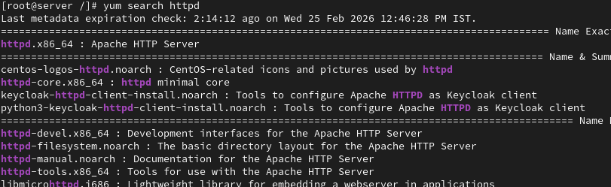

How can you update all installed packages using Yum?
yum update

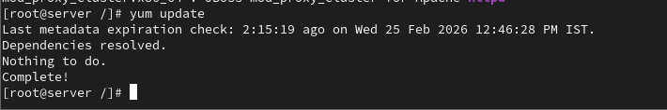

What is the purpose of repositories in Yum?
Purpose:
- Provide packages for installation
- Store updates and security patches
- Allow easy software management

How can you enable or disable a repository in Yum?

/etc/yum.repos.d/
Edit the repository file:
vi repo_name.repo
Change:
enabled=1 (enable repository)
enabled=0 (disable repository)

What command is used to list the enabled repositories in Yum?

yum repolist

How can you install a specific version of a package using Yum?
yum install package_name-version

What is the difference between Yum and RPM?
YUM | RPM
High-level package manager | Low-level package manager
Automatically resolves dependencies | Does not resolve dependencies automatically
Downloads packages from repositories | Installs local RPM files
Easier for package management | Used for manual package installation

How can you list the dependencies of a package using Yum?

yum deplist httpd

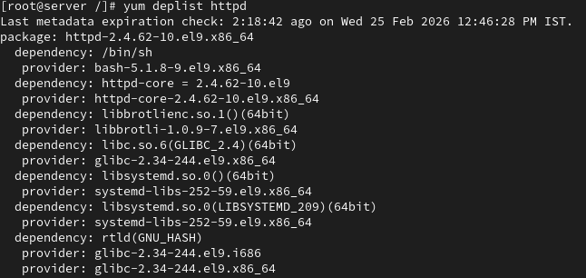

How can you install a package group using Yum?
yum groupinstall "Development Tools"

Yum repositories in Linux:
What is a Yum repository in Linux?
A Yum repository is a storage location that contains software packages (RPM files) and their metadata used by the Yum package manager.
It allows the system to:
- Install software
- Update packages
- Resolve dependencies automatically
How can you configure a custom Yum repository in Linux?
/etc/yum.repos.d/
Example:
vi /etc/yum.repos.d/myrepo.repo
Add the configuration:
[myrepo]
name=My Custom Repository
baseurl=http://example.com/repo/
enabled=1
gpgcheck=0

What is the purpose of the baseurl directive in a Yum repository configuration?

The baseurl specifies the location where the repository packages are stored.
Example:
baseurl=http://mirror.centos.org/centos/9/BaseOS/x86_64/os/

How can you remove a Yum repository from the system?

Delete the repository file from the repo directory:
rm /etc/yum.repos.d/repo_name.repo
After removal, clean the cache:
yum clean all

What is the role of the yum.repos.d directory in Yum repositories?
/etc/yum.repos.d/
stores all repository configuration files (.repo files).
Each file defines:
- Repository name
- Package location
- Repository status (enabled or disabled)
Yum reads this directory to identify available repositories.

What command is used to synchronize the metadata of a Yum repository?

yum makecache
Purpose:
- Downloads repository metadata
- Updates Yum cache
- Improves package search speed

What are some common Yum repository management commands in Linux?
Command | Purpose
yum repolist | List enabled repositories
yum repolist all | Show all repositories
yum makecache | Download repository metadata
yum clean all | Clear Yum cache
yum search package | Search packages in repositories
yum install package | Install package
yum update | Update packages

16. SSH
====
what is ssh?
t allows users to:
- Log in to remote systems
- Execute commands remotely
- Transfer files securely
port number of SSH?
The default port number of SSH is:
22

Is it possible to change ssh port number?
Yes, the SSH port number can be changed for security reasons.
Edit the SSH configuration file and change the port value.
Example:
Port 2222
Then restart the SSH service.

Write command to login remote machine in terminal?
ssh root@192.168.1.10

Write command to login local machine in terminal?
ssh ranjith@localhost

ssh configuration file location?
Main SSH server configuration file:
/etc/ssh/sshd_config
SSH client configuration file:
/etc/ssh/ssh_config

configure SSH key based authentication? write path of key file location? server1-user:admin1 to server2-user:admin1

Server1 user: admin1 → Server2 user: admin1
Step 1: Generate SSH key on Server1
ssh-keygen
Press Enter for default location.
Step 2: Copy public key to Server2
ssh-copy-id admin1@server2_ip
Example:
ssh-copy-id admin1@192.168.1.20
Now you can login without password.
ssh admin1@192.168.1.20

what is the command to generate the ssh key?

ssh-keygen

what is the command to copy the keys to remote machine?

ssh-copy-id admin1@192.168.1.20

when you generate the key what are files will be create?

/.ssh/

what is the ssh daemon name?
The SSH daemon service name is:
sshd
write ssh service-related commands which you know?

systemctl start sshd
Stop SSH:
systemctl stop sshd
Restart SSH:
systemctl restart sshd
Check status:
systemctl status sshd
Enable service at boot:
systemctl enable sshd
Disable service:
systemctl disable sshd

Disable ssh root login?
Edit SSH configuration file:
vi /etc/ssh/sshd_config
Change:
PermitRootLogin no
Restart SSH:
systemctl restart sshd

How to disable password-based authentication?

Edit:
vi /etc/ssh/sshd_config
Change:
PasswordAuthentication no
Restart SSH:
systemctl restart sshd

Allow ssh access to particular user? (user1, user2, user3)

Edit configuration:
vi /etc/ssh/sshd_config
Add:
AllowUsers user1 user2 user3
Restart SSH:
systemctl restart sshd

Change ssh port number 4044 and try to ssh login.

Edit SSH config:
vi /etc/ssh/sshd_config

Change:
Port 4044

Restart service:
systemctl restart sshd

Login using new port:
ssh -p 4044 user@server_ip

Example:
ssh -p 4044 admin1@192.168.1.20

How to start, stop, restart, check the status of ssh service?
Start:
systemctl start sshd
Stop:
systemctl stop sshd
Restart:
systemctl restart sshd
Status:
systemctl status sshd

How to start the ssh service permanently?
systemctl enable sshd

How to stop the ssh service permanently?
systemctl disable sshd

17. Analyzing and storing logs in Linux:
What is the purpose of log files in Linux?
Log files record system activities and events such as:
- System errors
- Security events
- User logins
- Application activity
- System performance information

How can you view the contents of a log file in Linux?

cat /var/log/messages

What command is used to search for specific keywords or patterns within a log file?
cat /var/log/messages

How can you filter log entries based on specific criteria using the grep command?
grep "error" /var/log/messages
What is the purpose of log rotation in Linux?
Log rotation is used to:
- Prevent log files from becoming too large
- Archive old logs
- Compress old logs
- Save disk space
- Maintain logs for a specific time period

How can you configure log rotation for a specific log file?
/etc/logrotate.conf

What is the significance of log levels in log files?

Level | Meaning
DEBUG | Debugging information
INFO | General information
WARNING | Possible problem
ERROR | Error occurred
CRITICAL | Serious system failure

How can you analyze logs for errors and warnings using regular expressions?
grep -E "error|warning|fail|critical" /var/log/messages

What are some commonly used log files in Linux?

Log File | Purpose
/var/log/messages | General system logs
/var/log/secure | Security and authentication logs
/var/log/cron | Cron job logs
/var/log/dmesg | Kernel boot messages
/var/log/maillog | Mail server logs

How can you monitor log files in real-time using the tail command?

tail -f /var/log/messages

What is the purpose of log analyzers and monitoring tools in Linux?

Log analyzers help to:
- Detect system errors
- Monitor security threats
- Analyze server performance
- Generate reports and alerts

How can you store logs remotely using a centralized logging server?
Edit configuration file:
/etc/rsyslog.conf
Add remote server:
*.* @192.168.1.100:514
Restart logging service:
systemctl restart rsyslog

What is the role of the /var/log directory in Linux?
/var/log
• System operations
• Services
• Security events
18. ACL
Set a read and write ACL for user bob on the file /home/user1/report.txt.

setfacl -m u:bob:rw /home/user1/report.txt
Explanation:
- -m → modify ACL
- u:bob:rw → user bob gets read & write

Remove all ACL entries for the file /var/log/syslog.

setfacl -b /var/log/syslog
Explanation:
- -b → remove all ACL entries

Grant the group developers read, write, and execute permissions on the directory /home/projects/, including all files and subdirectories.

setfacl -R -m g:developers:rwx /home/projects/
Explanation:
- -R → recursive (apply to all files and subdirectories)

Set a default ACL that gives the group marketing read-only access to all new files created in the directory /shared/marketing/.

setfacl -d -m g:marketing:r-- /shared/marketing/
Explanation:
- -d → default ACL (for newly created files)

Check and display all the ACL entries on the file /etc/hosts.
getfacl /etc/hosts
Explanation:
- getfacl → display ACL permissions

Set the user alice to have no permissions on the file /home/user2/confidential.txt, even though she belongs to the users group which has permissions.

setfacl -m u:alice:--- /home/user2/confidential.txt

Grant the user tom execute permission on the directory /scripts/ and all files inside it.

setfacl -R -m u:tom:x /scripts/

Modify the ACL of the file /data/project.txt to grant the user susan read and write permissions, but not execute permissions.

setfacl -m u:susan:rw- /data/project.txt

Set an ACL for the group admin to have full permissions (read, write, execute) on the file /etc/passwd, while keeping the original permissions for other users intact.

setfacl -m g:admin:rwx /etc/passwd

Create an ACL that removes write permissions for the group staff on the file /tmp/notes.txt, but allows the owner to retain full permissions.

setfacl -m g:staff:r-x /tmp/notes.txt

Important ACL Commands

Command |  | Purpose
setfacl -m | Modify ACL
setfacl -x | Remove specific ACL
setfacl -b | Remove all ACL
setfacl -R | Recursive ACL
setfacl -d | Default ACL
getfacl | View ACL

